**ARDUINO-BASED PAYMENT KIOSK AND**

**MONITORING SYSTEM**

##### i. Title Page

**A Kiosk Project Design - Pay Sync**

**Rakesh Kosambia**

(Brain, Designer, Developer & Implementor)

**May 2023**

##### vi. Table of Contents

1. *Title Page i.*
2. *Table of Contents ii.*
3. *List of Figures v.*
4. *List of Tables vi.*
5. *List of Appendices vii.*

1. Introduction 14

1.1. Background of the Problem 15

1.1.1. Existing VMF Bill Payment Process (8 Steps Process) 16

1.1.2. Key Goal Identification 18

1.2. Overview of the current state of technology 21

1.2.1. Disseminating the bills 21

1.2.2. Actual Payment 21

1.2.3. Payment Evidence 21

1.2.4. Google Form 21

1.2.5. Google Form Evidence 22

1.2.6. Email 22

1.2.7. Verification of Payment 22

1.2.8. Acknowledgement of Payment 22

1.3. Objectives of the study 23

1.3.1. Accept CASH payments & RECEIPT for payment 23

1.3.2. EASILY accessible to bill records 23

1.3.3. Physical security of the device 24

1.4. Scope and Limitations of the Study 24

1.4.1. Scope of Work 24

1.4.2. Limitations 24

2. Literature Review 26

2.1. Review of related literature, studies and/or systems 26

2.1.1. Local Studies 26

2.1.2. Local Systems 28

2.1.3. Foreign Studies 29

2.1.4. Foreign Systems 31

2.2. Synthesis 32

3. Methodology for Software Development Life Cycle (SDLC) 35

3.1. Planning 35

3.2. Data Gathering 36

3.3. Requirement Analysis 36

3.4. Designing the device 36

3.5. Development of device 37

3.6. Coding 37

3.7. Testing 38

3.8. Maintenance 38

4. Component Design, Data Flow, Schematic Diagram 39

4.1. Hardware Components 39

4.1.1. Touchscreen Display 39

4.1.2. Microcontroller 39

4.1.3. Bill Acceptor 39

4.1.4. Alarm System 40

4.1.5. Receipt Printer 40

4.2. Software Modules 40

4.2.1. Login Module 40

4.2.2. Homeowners Management Module 41

4.2.3. Homeowners’ Information Module 41

4.2.4. Bill Management Module 42

4.2.5. Reports Module 42

4.2.6. Authentication Module 42

4.2.7. Transaction History Module 43

4.2.8. Web Application Component 43

4.3. Data Flow Diagram 44

4.4. Block Diagram 47

4.5. Schematic Diagram 48

4.6. List of Hardware Components 49

4.7. Software Tools, Technology & Server 50

5. Test Results and Evaluation 51

5.1. Test Cases 51

5.2. Device Evaluation 53

5.3. Post-Evaluation Results 53

6. Conclusions & Recommendations 58

6.1. Conclusion 58

*6.2.* Recommendations 58

6.2.1. Expansion of Payment Options 59

6.2.2. Integration with Online Platforms 59

6.2.3. Continuous User Feedback and Iterative Development 59

6.2.4. Security Audits and Upgrades 59

6.2.5. Collaboration with Service Providers 59

7. References 61

8. Appendices 64

##### vii. List of Figures

**Figure 1.** Waterfall Model 35

**Figure 2**. Component Diagram 39

**Figure 3.** Dataflow Diagram for User Module 44

**Figure 4.** Dataflow Diagram for Admin Module 46

**Figure 5.** Block Diagram 47

**Figure 6.** Schematic Diagram 48

**Figure 7.** Survey and Interview with Homeowners 64

**Figure 8.** Interview with Dr Mauro Lucido 64

**Figure 9.** Interview with the Security Personnel 67

**Figure 10.** Interview with the random homeowner 68

**Figure 11.** *Board Resolution* 70

**Figure 12.** *Instructions* about *the Payment Process of VMF* 71

**Figure 13.** Google Forms questionnaires of the Home’s developer (Ovialand) 71

**Figure 14.** Google Forms proof with questionnaires 72

**Figure 15**. Format of Treasurers list for Members who paid or still unpaid VMF 72

**Figure 16.**  Subdivision’s population (2022-2023) 72

**Figure 17**. Subdivision’s population (2022-2023) 73

**Figure 18.** Results of Initial Survey with the Homeowners of Subdivision 73

**Figure 19.**Structural Design of the Payment Kiosk 75

**Figure 20.** Resume of Engineer Armida Contreras 77

##### viii. List of Tables

**Table 1.** Power Supply 50

***Table 3.*** *Peripheral devices* 50

**Table 4.** Computer System **Table 5.** Protective 50

**Table 6.** List of Software Tools, Technology & Server 51

***Table 7.*** *Test Case Scenarios* 52

***Table 8.*** *Performance Evaluation of the Device in terms of Functionality* 55

***Table 9.*** *Performance Evaluation of the Device in terms of Durability* 55

***Table 10.*** *Performance Evaluation of the Device in terms of Safety* 56

**Table 11.** Performance Evaluation of the Device in Terms of Marketability 57

***Table 12.*** *Performance Evaluation of the Device in terms of Aesthetics* 57

**Table 13.** Capstone Project Expenses 76

**Table 14.** Schedule for Development of Kiosk 77

##### iii. List of Appendices

viii. List of Appendices

# Introduction

s are the backbone of many country’s economies, with most of the population in some regions residing in rural areas. Efficient and reliable collection of maintenance fees is crucial for the smooth operation and management of subdivisions. However, the existing payment methods used by homeowners, such as bank deposits and online banking, have been fraught with challenges. Homeowners have reported issues with payment discrepancies, where their payments do not reflect as paid in their accounts, leading to confusion and disputes.

To address these issues, this study aims to propose an offline payment kiosk as a solution to streamline the payment process, improve accuracy, and ensure financial stability within the subdivision.

The objective of this project is to provide homeowners with a convenient and secure method of paying their maintenance fees. The proposed device will be a cash-only payment kiosk located at the entrance of the subdivision, allowing homeowners to easily make their payments without the need for online transactions or physical banking. By implementing the device, homeowners will have a convenient and accessible payment method that eliminates the need for online transactions or physical visits to banks. The kiosk will be equipped with an alarm system to prevent tampering and ensure the security of the device. Additionally, the payment records will be monitored and stored electronically, allowing the subdivision's administrative team to generate reports and maintain accurate financial records.

The device offers several advantages over traditional payment methods. It provides a centralized and easily accessible payment point for homeowners, reducing the time and effort required to make payments. The cash-only system eliminates the need for online banking or credit card transactions, making it more inclusive for homeowners who may not have access to these services. Furthermore, the alarm system adds an extra layer of security, ensuring the integrity of the payment process.

In conclusion, the Maintenance Payment Kiosk project aims to address the challenges associated with collecting maintenance fees within subdivisions. By providing an offline cash payment solution with monitoring capabilities, the project aims to enhance convenience, security, and financial inclusivity for homeowners. The proposed system has the potential to streamline fee collection processes, improve financial management, and contribute to the overall efficiency and sustainability of the subdivision's operations.

## Background of the Problem

Every homeowner is required to follow **VMF Bill Payment Process (8 Steps process)**

### **Existing VMF Bill Payment Process (8 Steps Process)**

1. VMF bill will be sent by PMO/Board of Directors via email to those Homeowners who opted to be communicated by email & all Homeowner will get physical the copy of the bills in their address boxes.
2. Homeowners will opt to pay VMF via either bank transfer or another online mode of payment.
3. Capture screen as evidence for transfer of funds.
4. Fill up the Google Form which is having 10 Questions to answer.
5. Again, need to screen-capture the evidence of the Google Form being submitted.
6. Lastly, they will email this evidence to the dedicated email of the Homeowner Association to inform them about the payment of VMF.
7. Now Treasurer of the Homeowner Association will verify the evidence of payments provided in the email with the actual payment transaction in the Homeowner Association Dedicated Bank Account.
8. After verification Treasurer will acknowledge the email and maintain the physical book of accounts. It will take a turnaround time of 2/3 days.

According to an interview with the homeowners, some or the majority of members cannot comply with the required procedures, and this leads to confusion between the Homeowners & PMO officers. The Homeowners unintentionally failed above all 8 steps, as they are not into Online payments, and emails & it makes it all the more difficult.

The above scenario marks them as unpaid on the treasurer’s list as rules are in place if there is no email received and/or survey forms, it means that the VMF is unsettled. The unsettled VMF of the homeowners lead to the delay on the whole subdivision’s budget for necessary purposes, like the salary for security and maintenance personnel.

### **Key Goal Identification**

* General Problem

The general problem is the inefficient and cumbersome maintenance fee payment process within subdivisions. The existing methods, such as bank deposits and online banking followed by manual processes, fail to provide a seamless and user-friendly experience for homeowners. This results in delays, discrepancies, and frustrations in the payment and financial management process. There is a need for a more efficient and reliable payment solution that can streamline the fee collection process, improve accuracy, and enhance overall financial management within subdivisions.

The general problem revolves around the inefficiencies and complexities of the current maintenance fee payment system within subdivisions. The existing methods lack automation, transparency, and real-time updates, leading to difficulties in accurately tracking payments, reconciling accounts, and generating timely financial reports.

Therefore, the problem focuses on how to create and engineer a device that can receive CASH payments from homeowners while also incorporating a monitoring system that showcases the payment history of each homeowner, including both paid and unpaid VMF.

Key goal identification is been broken down into the following 3 goals which need to be achieved.

1. **Need a device that should allow homeowners to pay the VMF using CASH as well as provide receipts as the homeowners’ proof of transaction.**

Homeowner Association President, Dr Mauro Lucido, stated in the researchers’ conducted interview (see Appendix B) that there are a long 8 Steps VMF Bill Payment Process on paying the VMF bills. The member of the homeowners will not be marked as paid if the treasurer hasn’t received an email from the homeowners with proof.

The long process of payment leads to the confusion was evident when a homeowner was interviewed randomly. If records of the paid VMF are not updated via email to Treasurer then even paid bills are been marked as unpaid. According to the homeowners, the mentioned process of online payment is inconvenient. Also, due to the emergence of scammers and hackers, homeowners don’t prefer to transact online.

1. **Need a Payment System which should be easily accessible to both the Homeowner & PMO/Board of Directors (BOD) instead the Homeowner after payment still needs to provide proof of payment.**

After collecting data on the existing process as well as an interview conducted about the existing process, it was clear & evident as after the payments by the homeowner still PMO Staff or BOD (elected Board of Directors who voluntarily performed PMOs some of the admin activities) will have to check Email, Google Forms & cross verify Bank Accounts with the Google Form/Email information provided.

Above all concludes there is no central place of reference after payment is done by Homeowner to refer & the same information is viewed by PMO Staff/Volunteers to maintain their physical records for the payments.

1. **Need a device with an alarm system which should trigger if someone is trying to force rob payments, collected in the kiosk.**

According to Smith (2008), the public kiosk that exists privately have internal networks which are the same as the cash registers and has unmonitored access to the system. Although the VMF payment kiosk is placed near the security personnel, there were still a threat of theft because money is involved.

## Overview of the current state of technology

The following processes and platforms are used in the current billing method - VMF Bill Payment Process (8 Steps Process) of Home Subdivision – San Pablo.

### **Disseminating the bills**

The security guard of the subdivision is the one who delivers the bills printed by the treasurer to every house. The bills are printed on a piece of paper with the homeowner’s name and amount for payment. According to the subdivision’s security personnel, it takes a whole week for them to completely distribute the bills with a total of 557 homeowners.

### **Actual Payment**

The monthly maintenance dues were transacted online. For online transactions, Bank Account application. After the payment, the user needs to screen capture the online receipt, then it will be sent to the Google Forms provided wherein the user will fill out some personal details and upload the receipt as proof of payment.

### **Payment Evidence**

Actual Payment transactions need to be captured as screen capture or picture need to be maintained as evidence.

### **Google Form**

The use of Google Forms is to create online forms and surveys with multiple question types. The platform analyzes results in real time and from any device. The Google Form provides the details sent by the homeowners, together with the screen-captured receipts. After receiving an update from a specific member, the treasurer will check the Google form to verify the information answered by the homeowners. This part of the process is important for the Homeowner Association in keeping records with the paid and unpaid homeowners.

### **Google Form Evidence**

Screen capture or picture needs to be maintained as evidence as Google Form has been submitted as evidence.

### **Email**

The process will not be completely done without sending the receipts and screen capture of the submitted Google form to the PMO/BOD official email account.

### **Verification of Payment**

The treasurer of the will checks daily the association’s email account if there are any updates from the members regarding the payment. If found one will cross, verify the payment detail with the Bank Account. If the homeowners failed to send the required data to the email account, the record of payment will not be stated in the Account of Payment List.

### **Acknowledgement of Payment**

PMO/BOD (Treasurer) records VMF payment records in physical/MS Excel as the record of proof only after verification will acknowledge & marked it as paid else there is a penalty for unpaid bills.

## Objectives of the study

The main objective of the study is to design and develop an offline payment kiosk that improves the payment process and ensures accurate payment reflection in homeowners' accounts as identified in key goals to achieve. This solution aims to address the existing problems within the subdivision's payment system by streamlining the process and reducing payment discrepancies and disputes

### Accept CASH payments & RECEIPT for payment

To facilitate homeowners' payment of the VMF using cash and provide them with transaction receipts, the developers will design and develop a device.

This device should enable homeowners to pay their outstanding bills by inserting cash notes of denominations 20, 50, 100, 200, 500, and 1000.

Additionally, the device should have the capability to generate printed receipts as evidence of successful transactions.

### EASILY accessible to bill records

Need a Payment System which should be easily accessible to both the Homeowner & PMO/Board of Directors (BOD) instead the Homeowner after payment still needing to provide proof of payment.

The objective of the device is to keep records of the payment transaction in the same system which is used to pay the bills using CASH.

The system will allow the management to check the paid and unpaid members including the balances. The system will generate reports like Received Amount and Pending Amounts references for the treasurer to have a common place of records.

### Physical security of the device

A physical security device needs to have an alarm which should help protect against theft by force moving the device.

The device will be placed in a secure area wherein the security guards and CCTV cameras are placed. The officers and security guards will be notified once the alarm triggers to come up with further actions.

## Scope and Limitations of the Study

### Scope of Work

1. Device should allow homeowners to pay the VMF using CASH as well as provide receipts as the homeowners’ proof of transaction.
2. Need a Payment System which should be easily accessible to both the Homeowner & PMO/Board of Directors (BOD) instead of the Homeowner after payment still needing to provide proof of payment.
3. Need a device with an alarm system that should trigger if someone will try to force rob payments collected in the kiosk.

### Limitations

* Miscellaneous or other fees

The device only accepts the Maintenance Fee (VMF) of the homeowners. Any other bills to be paid by the homeowners like loans, electricity bills, water bills, etc. are not covered by the device.

* Mode of Payment (MOP)

The device only accepts CASH as payment, no coins, no card is involved during transactions. Also, the system cannot dispense any CASH back. Homeowners need to pay exact money for the payment.

* Distribution of the VMF billing statements

The device cannot be used to send VMF billing statements electronically via SMS, EMAIL, etc. to homeowners.

* Internet Connectivity

The device will operate OFFLINE. However, this limitation may restrict real-time updates and synchronization of account information until the device is connected to the internet. Hence sync is to be done manually via a copy of data by ADMIN staff in a thumb drive after valid login authentication to the device.

# Methodology for Software Development Life Cycle (SDLC)

## Planning

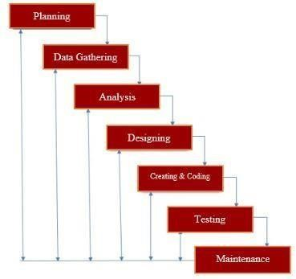During this phase, the developers came together to discuss various ideas and address the societal issues at hand. The researchers identified challenges with the payment process for the Maintenance Fee (VMF) within the Homes

**Figure 1.** Waterfall Model

Subdivision in San Pablo, which was overseen by the Homeowners' Association's Board of Directors.

The members initially discovered the billing system and found it promising but encountered issues due to the manual processing done by the Board of Directors. The developers concentrated on the problem based on the client’s feedback and put forth a potential solution.

Planning also includes costing or estimating the possible cost of the modules and materials to be used for the whole project. There are also hardware and software involved in the study as part of the planning phase.

## Data Gathering

The developers studied the problem by gathering data and conducting interviews. The data gathered came from other studies depicting the advantages and disadvantages of payment transactions through technology. The developers conducted an interview and survey with the BOD and homeowners inside the subdivision to specify the existing problem.

Furthermore, the data gathered from the different studies and interviews were combined by the researchers to improve the initial possible solution. Statistical data was gathered and computed to see the problem and come up with a possible solution for dealing with the issues.

## Requirement Analysis

This phase determines the client’s expectation for a modified product that could help solve the existing problem of the organization. The developers listed the required data gathered from the client and converted the problems into functional specifications that would solve such problems. The features and designs are the components needed for useful devices and software that could solve the current problem of the HOA’s billing system.

## Designing the device

The developers made an architectural design, modules, data, and interfaces for the device that is connected to software to satisfy the specific requirements. This process shows the components of the device including its desktop application. The design of the device will be initially done in a software application to visually represent the whole idea of the device. The design will set a pattern for building the device and buying the materials needed.

Same as the software application which is specified as a desktop application. The application will be designed using visual representation before proceeding with the actual coding and making of the system. The software design must be coordinated with the different modules available on the device.

## Development of device

This phase will cater to all the steps for doing the actual device with the proposed design as its basis. The modules and materials needed are seen in this phase together with the schematic diagrams for the proper wiring connections. Every detail from the given design will be observed in this phase to fulfil the required architectural design.

The developers will not be based on the initial design. There will be instances when the actual material will not fit on the whole device. Further revisions and improvements while creating the device are possible depending on the aligned functions for each module.

## Coding

This phase will focus on the structure of the software, including its design. The programs are coordinated with the data and can control the entire process in the device. This phase will also test the errors or bugs regarding the modules. An error from the modules, especially the wiring will lead to malfunctioning software. That’s why a proper creation of a device must be done first to avoid errors when coding. Since the methodology is a modified waterfall, the developers will go back to the creation of device to test if something is not doing its functions to completely proceed with the coding. Trial and error will be mostly observed in this phase to come to the right coding.

## Testing

This phase will test the whole built device, the hardware and the software application. The developers will do the testing the of device. Each module will be tested according to its functions. The module must interact with the input of the user according to its program.

During this phase, an error and defect will be traced. The device testing will be done wholly to know what to add or improve. Most importantly, to check if the service of the device satisfies the requirements of the client. The developers will first test the device using money and fake money, to see if the credits were placed on the database, and see if it prints a receipt after the transaction.

The testing of the bill acceptor, the LCD module, the printing of receipts, the alarm system, the desktop application, and the whole transaction step-by-step process will be done during this phase.

## Maintenance

This phase will keep the implemented device functioning by checking it regularly with the developers to ensure that the group had made a well-functioning product in a long amount of time. The developers will address further issues that are discovered to prevent failure on the expected performance of the device and to make further actions like updating something.

Also, PMO/BOD representative will contact the developers if there are errors and failures in the functionalities of the device. A monthly maintenance check will be done by the developers to ensure that the device is giving the desired service needed by the homeowners. Further suggestions and recommendations from the HOA will be accepted by the developers.

# Component Design, Data Flow, Schematic Diagram

System visualization of a device to be developed is as below

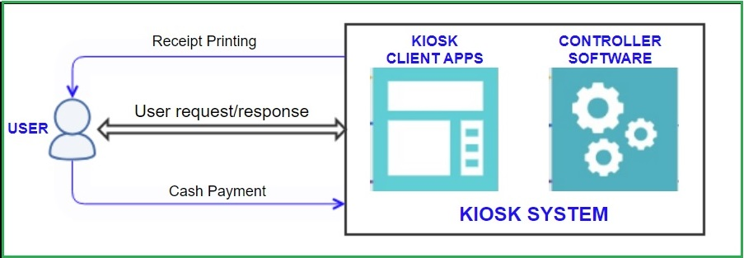

**Figure 2**. Component Diagram

## Hardware Components

### Touchscreen Display

The kiosk device will have a touchscreen display that will show the payment transaction process including the date, the name of the homeowners with block and lot number, and the unpaid bills that needs to be settled. This module will use touch panels to enable the user to interact with the device.

### Microcontroller

This will perform all tasks based on the input of the user, the sensor data reading, and the data transferred. The microcontroller will also provide a power source for the modules mentioned in the study. This module will process all the data thrown by the different hardware and modules connected, this will then be visually represented through software.

### Bill Acceptor

This module contains a bill acceptor that identifies counterfeit money with the aid of a money detector, reports cases of fake money, arranges bundles of money and maintains the money detector/money counter machine. The bill acceptor will not accept fake money from the user.

### Alarm System

The device includes an alarm system that triggers when there is a possible threat of theft from an unauthorized person. To prevent such crimes, an alarm system is integrated inside the device to notify the security personnel and the PMO/BOD representative who is in charge of managing the VMF. This module will be triggered if there is a possible detection of imbalances and movements from the physical device.

### Receipt Printer

The device is designed to print the proof of a successful transaction process on the payment of the Maintenance Fee (VMF). The device has printing modules which contain a thermal printer component and use thermal paper. The printed receipt includes the date of the transaction, the name of the Homeowners and the payment transaction.

## Software Modules

A kiosk client app is a software program that can be run on a standalone computer to perform a specific task by an end-user. The developers will develop a desktop application to be the running software of the device. The application is only accessible for the authorized officers of the association to visit to check the homeowners’ VMF information. This includes the name of the homeowners, the paid and unpaid VMF of each homeowner, the date and time of every transaction and the total number of funds acquired.

### Login Module

A login module is a component of a system that handles the authentication process for homeowners. It typically prompts the user to input a username and password to gain access to the system or perform specific operations. The login module verifies the provided credentials in the system database.

The login module provides a secure and controlled mechanism for homeowners to authenticate and gain access to their previous and current transactions. This module includes the protection of sensitive information and ensuring that only authorized individuals can use the system.Top of Form

### Homeowners Management Module

This module allows the system admin to add and register homeowners. The admin can input essential details such as the homeowner's name, contact information, address, and any other relevant information required for proper record-keeping.

This module also includes the homeowner records management wherein the admin can update or modify existing homeowner records as needed. This includes editing personal information, contact details, and other relevant data. Additionally, the admin may have the ability to delete homeowner records in case of resident relocation or other circumstances.

### Homeowners’ Information Module

This module will provide all the information required for the device to identify the members of the subdivision. The name, block and lot number of every homeowner will be seen in this module so that the device can show identity to the homeowners and the HOA which will then be related to the amount of the homeowner’s VMF. The information will be input by the billing officer as they have access to every homeowner’s information.

### Bill Management Module

The admin has the authority to add bills or invoices to the system for homeowners to view and pay. This includes specifying the amount due, the due date, and any additional details regarding the bill, such as the purpose or description.

* Billing History

The module may also provide a billing history feature, allowing the admin to view and track past bills and payments made by homeowners. This enables comprehensive financial record-keeping and facilitates easy reference for both the admin and homeowners.

### Reports Module

The developers will use a database as part of keeping the homeowners’ transaction records. This report will be relevant to the management to avoid confusion when it comes to the paid and unpaid members. This module also includes the total amount acquired from the payments. The monitoring system is included in this module which is connected to the software application.

The reports module is responsible for generating and presenting various reports that provide valuable insights and information related to the financial transactions and activities within the subdivision. This module consolidates data from different sources and presents it in a structured and meaningful format for analysis and decision-making purposes.

### Authentication Module

This module handles the login process for homeowners. It verifies their username and password and grants access to their accounts. User Account Management Module This module allows homeowners to view their account information, such as their real name, address, contact email, and phone number. It also enables homeowners to change their passwords for added security.

### Transaction History Module

This module maintains a record of homeowners' transaction history, displaying details such as payment dates, amounts, and payment statuses. It provides homeowners with visibility into their past transactions. Payment Processing Module This module facilitates the payment process for homeowners. It enables homeowners to pay their maintenance bill using their cash, calculates the payment amount, and generates receipts for each transaction.

### Web Application Component

Eclipse IDE Integrated Development Environment for developing and managing web applications. HTML Responsible for creating the structure and layout of the user interface. CSS Handles the styling and visual presentation of the user interface. JavaScript Manages client-side interactivity and the behavior of the user interface. JSP Handles server-side processing and dynamic content generation. Server Component Apache Tomcat Web server and servlet container that hosts the web application. Java Servlets Handle user requests, perform business logic operations and interact with the data access layer. MySQL Manages the database where user information, transaction data, and other relevant data are stored. JDBC Enables connectivity to the MySQL database and performs database operations. Device Integration Layer Arduino IDE Development environment for programming the Arduino board and handling hardware interactions. Arduino Firmware Custom firmware developed using Arduino IDE to communicate with hardware components such as the bill acceptor, receipt printer, buzzer, shock sensor, etc. External Service Layer Web2Catalog enables the conversion of web applications into standalone.

## Data Flow Diagram

**Figure 3.** Dataflow Diagram for User Module

Figure 3. depicts the series of steps involved when a user interacts with a system. It commences with the user agreeing to the terms and conditions. If the user responds with "Yes," the sequence continues; otherwise, it terminates.

Next, the user will be prompted to log in by providing a username and password. If the supplied credentials are correct, access will be granted, and the process proceeds. In the event of incorrect credentials, an error message will be displayed, and the process returns to the login stage to allow the user to enter the correct details.

Upon successful login, the system presents the user with a menu displaying various options. The user can choose an option from the menu, and the subsequent actions depend on the selected choice.

If the user selects Option 1, the system will display the homeowner's information.

If the user selects Option 2, the system will display the bill information, followed by the option to pay the bill. If the user chooses to make a payment, the system will present the payment page.

To proceed with the payment, the user should click the "start payment" button, which initiates the payment process. Alternatively, the user can choose another option from the menu or end the process by selecting the logout option. After clicking the "start payment" button, the user will be prompted to insert cash for payment.

Once the payment is completed, the user needs to confirm, and the system displays the amount that was inserted.

Finally, the user must submit the payment by clicking the "submit payment" button, which will redirect them to a page where the receipt is displayed. The user has the option to print or not print the receipt. Regardless of the choice made, the system will automatically log out.

Lastly, if the user selects Option 3, the system displays the transaction records.

The process then proceeds to the next step, where the user is prompted to log out of the system. If the user chooses to log out, the process ends. If the user wishes to continue interacting with the system, the process returns to the menu options.

This flowchart represents a simplified process flow for agreeing to terms, logging in, accessing different options, making a bill payment, printing a receipt, and logging out.

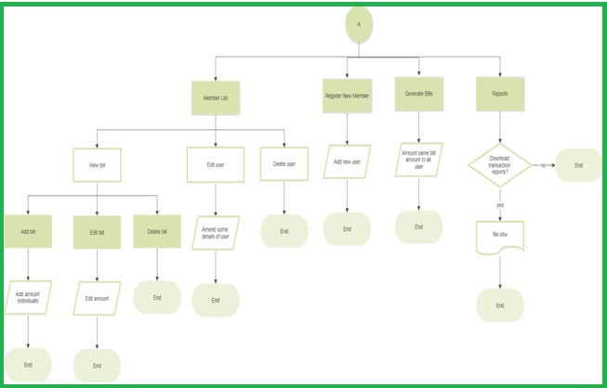

**Figure 4.** Dataflow Diagram for Admin Module

Figure 4. outlines the steps and decision points involved in interacting with the system, including managing member information, registering new members, handling payments, and performing administrative tasks like generating reports and managing user accounts. It begins with the admin agreeing to the terms and conditions. If the admin responds with "Yes," the sequence continues; otherwise, it terminates.

Next, the admin will be prompted to log in by providing a username and password. If the credentials are correct, access is granted, and the system displays the menu.

The user is then prompted to choose from a list of menu options, which include viewing a list of members, registering a new member, and checking received payment amounts. Depending on the user's selection, different actions are taken.

If the user selects sub-menu option 1 of the option 1 menu, they can add a bill to homeowners. Option 2 allows them to update user details, and option 3 enables them to delete user.

Throughout the process, various actions are performed based on the user's choices, such as displaying member details, showing a registration form, totaling received payment amounts, adding bills to homeowners, editing user details, and deleting user accounts.

## Block Diagram

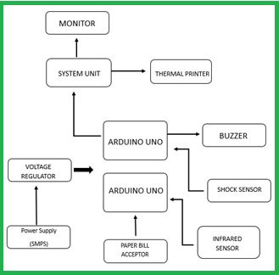Figure 5 shows the devices that are connected to the Microcontrollers – Arduino Uno. The microcontroller is where all the nodes are interconnected for the whole system as well as the computer software and the calculations will be processed efficiently. The figure above shows the major components of the device – which are represented by blocks.

**Figure 5.** Block Diagram

## Schematic Diagram

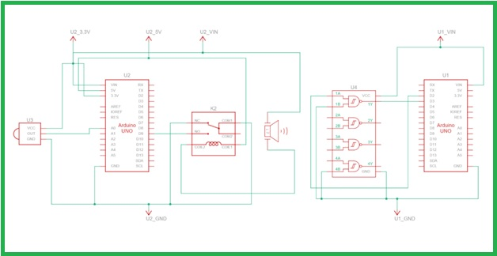

**Figure 6.** Schematic Diagram

The figure above shows the schematic diagram of the Maintenance Fee Payment Kiosk. The device uses a switched-mode power supply (SMPS) that transfers power from a DC or AC source to DC loads. It is connected to the voltage regulator that converts power from 220 VAC to 5 volts. The 5V power from the voltage regulator is then supplied to the Arduino Uno. The developers used two (2) microcontrollers for the avoidance of delay in the system. The Arduino Uno is connected to the system unit, monitor, and bill acceptor. The MCU is linked to the alarm system – shock sensor and buzzer. The thermal printer is connected to the System Unit.

## List of Hardware Components

**Table 1.** Power Supply

***Table 2.*** *Peripheral devices*

**Table 3.** Computer System **Table 4.** Protective

Enclosure for Kiosk

## Software Tools, Technology & Server

**Table 5.** List of Software Tools, Technology & Server

# Test Results and Evaluation

This chapter presents the compiled findings and insightful discussions derived from extensive testing conducted by the developers. Based on multiple trials and experiments, the team worked diligently to achieve the desired results.

## Test Cases

This section presents the results and discussion of the tests carried out by the developers. Multiple trials and experiments were done to achieve the specific target results.

***Table 6.*** *Test Case Scenarios*

|  |  |  |  |
| --- | --- | --- | --- |
| **Test Case** | **Scenario** | **Expected Result** | **Result** |
| User Authentication | Valid login credentials | Pass | The user can log in successfully. |
| User Authentication | Invalid login credentials | Pass | An error message is displayed for invalid credentials. |
| User Account Management | View account information | Pass | User can view their account details. |
| User Account Management | Change password | Pass | User can change their password. |
| Transaction History | View transaction history | Pass | User can see their transaction history. |
| Transaction History | Filter transaction history | Pass | Users can filter transactions successfully. |
| Payment Processing | Submit payment | Pass | Users can submit a payment successfully. |
| Payment Processing | Generate receipt | Pass | The receipt is generated for each payment. |
| Admin Portal | Manage bills (add, edit, delete) | Pass | Admin can perform bill management tasks. |
| Admin Portal | Manage user accounts | Pass | Admin can manage user accounts. |
| Invalid Payment Amount | Rejection of invalid payment amount | Pass | Invalid payment amounts are rejected. |
| View Unpaid Homeowners | Display a list of unpaid homeowners | Pass | A list of unpaid homeowners is displayed. |
| Handle Concurrent User Sessions | Manage multiple concurrent user sessions | Pass | Multiple user sessions are handled effectively. |
| Error Handling | Graceful handling of errors/exceptions | Pass | Errors and exceptions are handled gracefully. |
| Cross-Browser Compatibility | Consistent functionality across different browsers | Pass | Functionality is consistent across different sizes of windows. |
| Performance Testing | Satisfactory performance under high load | Pass | The system performs well under high loads. |
| Alarm System Testing | Triggered by the presence of any vibration and/or motion. | Pass | When motion is detected, the alarm system emits a buzzing sound continuously. |
| Launch and Connectivity Testing | should launch successfully in offline mode without any errors or connectivity dependencies | Pass | launches without errors and does not require an active internet connection for operation |

The provided test case table presents a comprehensive overview of the testing process and its outcomes. It outlines various scenarios and corresponding expected results, allowing for a clear evaluation of the system's functionality and performance.

The test cases cover different aspects of the system, ranging from user authentication and account management to transaction history, payment processing, and administrative tasks. Each scenario is accompanied by a result indicating whether the test was successful or not, and an expected result that defines the anticipated outcome for that specific test case.

The tests encompass both positive and negative scenarios, ensuring that the system behaves correctly under different conditions. For example, in user authentication, the system successfully allows users to log in with valid credentials while displaying an error message for invalid login attempts.

Furthermore, the table includes tests related to user account management, transaction history, payment processing, administrative tasks, error handling, cross-browser compatibility, performance under high load, alarm system functionality, and launch/connectivity testing.

The results demonstrate that the system performs as expected, with most of the tests passing successfully. This indicates that the software meets the specified requirements and functions correctly across different scenarios and conditions.

Overall, the test case table provides a comprehensive assessment of the system's behaviors and performance, ensuring that it meets the necessary criteria for reliable and efficient operation.

## Device Evaluation

The developers let the homeowners test the device inside the subdivision. Furthermore, they had provided a video presentation to demonstrate to the homeowner during the house-to-house survey how the device was being operated and utilized. The tests and video were presented to the respondents during the survey which will further determine the level of acceptability of the device from the criteria stated in the research instrument. The respondent of the study includes a sample size of 161 homeowners in Subdivision – San Pablo City.

## Post-Evaluation Results

Performance of the Payment Kiosk in terms of Functionality, Durability, Safety, Marketability, and Aesthetics is provided in tables that present the performance evaluation results of a payment kiosk device across different aspects: functionality, durability, safety, marketability, and aesthetics. Each table consists of indicators related to the specific aspect being evaluated, along with the mean, standard deviation, and a verbal interpretation of the results. These tables provide a comprehensive evaluation of the payment kiosk device's performance across different aspects, giving insights into its strengths and areas of acceptability. The evaluation helps gauge the device's viability, market potential, and homeowner perception in terms of functionality, durability, safety, marketability, and aesthetics.

|  |  |  |  |
| --- | --- | --- | --- |
| Indicators | Mean | Standard Deviation | Verbal Interpretation (VI) |
| The device is easy to operate. | 3.57 | 0.57 | Highly Acceptable |
| The device is working according to its function. | 3.68 | 0.47 | Highly Acceptable |
| The device is accurate. | 3.44 | 0.59 | Acceptable |
| The device provides comfort and convenience. | 3.55 | 0.50 | Highly Acceptable |
| The parts are installed properly. | 3.57 | 0.54 | Highly Acceptable |
| Overall | 3.56 | 0.04 | Highly Acceptable |

|  |  |
| --- | --- |
| **Legends:** | |
| 3.50-4.00 | :Strongly Agree (SA)/Highly Acceptable |
| 2.50-3.49 | :Agree (A)/Acceptable |
| 1.50-2.49 | :Disagree (DA)/ Somewhat Acceptable |
| 1.00-1.49 | :Strongly Disagree (SD)/Not Acceptable |

***Table 7.*** *Performance Evaluation of the Device in terms of   
Functionality*

Table 7 above shows the Performance Evaluation of the Device in terms of Functionality. The table assesses the device's functionality. It includes indicators such as ease of operation, accuracy, and comfort/convenience. The mean, standard deviation, and verbal interpretation suggest that the device performs highly acceptably in terms of functionality to the homeowners of Subdivision.

|  |  |  |  |
| --- | --- | --- | --- |
| Indicators | Mean | Standard Deviation | Verbal Interpretation (VI) |
| The materials used are durable. | 3.68 | 0.49 | Highly Acceptable |
| The device used quality materials. | 3.63 | 0.50 | Highly Acceptable |
| The device meets the operating limits. | 3.63 | 0.49 | Highly Acceptable |
| The device can withstand changing temperatures. | 3.48 | 0.54 | Acceptable |
| The device can adapt to the environment. | 3.58 | 0.53 | Highly Acceptable |
| Overall | 3.60 | 0.03 | Highly Acceptable |

|  |  |
| --- | --- |
| **Legends:** | |
| 3.50-4.00 | :Strongly Agree (SA)/Highly Acceptable |
| 2.50-3.49 | :Agree (A)/Acceptable |
| 1.50-2.49 | :Disagree (DA)/ Somewhat Acceptable |
| 1.00-1.49 | :Strongly Disagree (SD)/Not Acceptable |

***Table 8.*** *Performance Evaluation of the Device in terms of Durability*

Table 8 above shows the Performance Evaluation of the Device in terms of Durability. This table focuses on the device's durability. It examines indicators such as the durability of materials, meeting operating limits, and adaptability to changing temperatures. The mean, standard deviation, and verbal interpretation indicate that the device is highly acceptable in terms of durability to the homeowners of Subdivision.

|  |  |  |  |
| --- | --- | --- | --- |
| Indicators | Mean | Standard Deviation | Verbal Interpretation (VI) |
| The device is free from toxic/ hazardous materials. | 3.39 | 0.68 | Acceptable |
| The device has safety labels. | 3.31 | 0.72 | Acceptable |
| The device has no sharp edges. | 3.44 | 0.75 | Acceptable |
| The device is safe to operate | 3.53 | 0.51 | Highly Acceptable |
| The metals are properly installed. | 3.47 | 0.54 | Acceptable |
| Overall | 3.43 | 0.11 | Acceptable |

|  |  |
| --- | --- |
| **Legends:** | |
| 3.50-4.00 | :Strongly Agree (SA)/Highly Acceptable |
| 2.50-3.49 | :Agree (A)/Acceptable |
| 1.50-2.49 | :Disagree (DA)/ Somewhat Acceptable |
| 1.00-1.49 | :Strongly Disagree (SD)/Not Acceptable |

***Table 9.*** *Performance Evaluation of the Device in terms of Safety*

Table 9 above shows the Performance Evaluation of the Device in terms of Safety. This table evaluates the device's safety features. Indicators include the absence of toxic/hazardous materials, safety labels, and absence of sharp edges. The mean, standard deviation, and verbal interpretation suggest that the device's safety performance is acceptable to the homeowners of Subdivision.

**Table 10.** Performance Evaluation of the Device in Terms of Marketability

|  |  |  |  |
| --- | --- | --- | --- |
| Indicators | Mean | Standard Deviation | Verbal Interpretation (VI) |
| The device is low-cost and affordable. | 3.34 | 0.68 | Acceptable |
| The device is suitable for the needs of the community/homeowners. | 3.31 | 0.72 | Acceptable |
| The device is usable. | 3.54 | 0.75 | Highly Acceptable |
| The device is comparable to the existing product in the market. | 3.43 | 0.51 | Acceptable |
| The device has novelty and has the potential for a patent. | 3.42 | 0.54 | Acceptable |
| Overall | 3.41 | 0.09 | Acceptable |

|  |  |
| --- | --- |
| **Legends:** | |
| 3.50-4.00 | :Strongly Agree (SA)/Highly Acceptable |
| 2.50-3.49 | :Agree (A)/Acceptable |
| 1.50-2.49 | :Disagree (DA)/ Somewhat Acceptable |
| 1.00-1.49 | :Strongly Disagree (SD)/Not Acceptable |

Table 10 above shows the Performance Evaluation of the Device in terms of Marketability. This table assesses the marketability of the device. Indicators include affordability, suitability for community needs, usability, comparability to existing products, and potential for a patent. The mean, standard deviation, and verbal interpretation indicate that the device's marketability is acceptable to the homeowners of Subdivision.

***Table 11.*** *Performance Evaluation of the Device in terms of Aesthetics*

|  |  |  |  |
| --- | --- | --- | --- |
| Indicators | Mean | Standard Deviation | Verbal Interpretation (VI) |
| The design has novelty. | 3.62 | 0.68 | Highly Acceptable |
| The colour provides visual comfort to the design. | 3.52 | 0.72 | Highly Acceptable |
| The size of the design is proportional. | 3.42 | 0.75 | Acceptable |
| The design is appropriate to its function. | 3.50 | 0.51 | Highly Acceptable |
| The design is gender-sensitive in nature. | 3.39 | 0.54 | Acceptable |
| Overall | 3.49 | 0.03 | Acceptable |

|  |  |
| --- | --- |
| **Legends:** | |
| 3.50-4.00 | :Strongly Agree (SA)/Highly Acceptable |
| 2.50-3.49 | :Agree (A)/Acceptable |
| 1.50-2.49 | :Disagree (DA)/ Somewhat Acceptable |
| 1.00-1.49 | :Strongly Disagree (SD)/Not Acceptable |

Table 11 shows the Performance Evaluation of the Device in terms of Aesthetics. This table focuses on the aesthetics of the device. It examines indicators such as novelty in design, visual comfort, proportionality, appropriateness to function, and gender sensitivity. The mean, standard deviation, and verbal interpretation suggest that the device's aesthetics are acceptable to the homeowners of Subdivision.

# Conclusions & Recommendations

In conclusion, the development of the cash-based kiosk system has addressed the need for an efficient and user-friendly solution for homeowners and administrators in managing transactions and accessing essential information.

Through the implementation of a modified waterfall approach, we were able to successfully design, develop, and deploy the kiosk system, incorporating key features such as user authentication, transaction history, and payment capabilities. The system has demonstrated its value in streamlining processes, enhancing security, and improving user satisfaction within the target community.

## Conclusion

In conclusion, the development of the cash-based kiosk system has addressed the need for an efficient and user-friendly solution for homeowners and administrators in managing transactions and accessing essential information.

Through the implementation of a modified waterfall approach, we were able to successfully design, develop, and deploy the kiosk system, incorporating key features such as user authentication, transaction history, and payment capabilities. The system has demonstrated its value in streamlining processes, enhancing security, and improving user satisfaction within the target community.

## Recommendations

Based on our experience and the insights gained during the development and deployment of the cash-based kiosk system, we offer the following recommendations for further enhancement and future research:

### Expansion of Payment Options

While the current system supports cash payments, there is potential for integrating additional payment methods such as electronic transfers or mobile payments. By offering a broader range of payment options, homeowners can have more flexibility in settling their dues, thus further improving convenience and customer satisfaction.

### Integration with Online Platforms

Consider integrating the cash-based kiosk system with existing online platforms, such as a web portal or mobile application, to provide homeowners with access to their accounts and transaction history remotely. This would enable them to conveniently view and manage their information, even outside of the kiosk environment, fostering a seamless user experience.

### Continuous User Feedback and Iterative Development

Establish a feedback mechanism to collect insights from homeowners, administrators, and other stakeholders regularly. Actively engage users to gather their feedback on the system's usability, functionality, and any areas for improvement. This user-centric approach will enable ongoing iterative development and refinement of the kiosk system, ensuring its relevance and effectiveness over time.

### Security Audits and Upgrades

Regular security audits should be conducted to identify any vulnerabilities in the system and implement necessary upgrades to safeguard user data and financial transactions. As technology evolves and new threats emerge, it is essential to stay updated with the latest security practices and measures to maintain the system's integrity and protect user privacy.

### Collaboration with Service Providers

Establish partnerships or collaborations with relevant service providers, such as utility companies or payment processors, to enable seamless integration with their systems. This would facilitate automated bill generation, real-time payment processing, and accurate tracking of homeowners' financial records, further enhancing the efficiency and convenience of the cash-based kiosk system.

By implementing these recommendations, the cash-based kiosk system can continue to evolve and adapt to the changing needs and expectations of homeowners and administrators. The success of the system relies on continuous improvement, user-centric design, and proactive engagement with stakeholders, ultimately contributing to a more streamlined and efficient transaction management process within the target community.

# References

Book: Smith, J. (2020). The Power of Technology: Revolutionizing Homeowner Associations. Publisher.

Journal Article: Johnson, A., & Davis, B. (2018). Streamlining Payment Systems in Homeowner Associations. Journal of Property Management, 25(2), 45-60.

Website: Homeowner Association Website. (2022). Retrieved from [URL]

Conference Paper: Brown, M., & Wilson, S. (2019). Innovations in HOA Payment Systems. In Proceedings of the Annual HOA Conference (pp. 123-135). Publisher.

S.H. June, J.H. Kim, "Theoretical Background and Prospects for the Untact Industry",

Journal of New Industry and Business, Vol.38. Vol. 1, pp. 96-116, June 2020. DOI:10/30753/emr.2020.38.1.005

Raj, M. M. E., & Julian, A. (2015, March). Design and implementation of anti-theft ATM machines embedded systems. In 2015 International Conference on Circuits, Power and Computing Technologies [ICCPCT-2015] (p. 1-5). IEEE.

E. B. B. Palad, M. S. Tangkeko, L. A. K. Magpantay and G. L. Sipin, "Document

Classification of Filipino Online Scam Incident Text using Data Mining Techniques," 2019 19th International Symposium on Communications and Information Technologies (ISCIT), 2019, pp. 232-237, Doi:

10.1109/ISCIT.2019.8905242.

Palad, E. B. B., Tangkeko, M. S., Magpantay, L. A. K., & Sipin, G. L. (2019, September).

Document classification of Filipino online scam incident text using data mining techniques in 2019 19th International Symposium on Communications and Information Technologies (ISCIT) (pp. 232-237). IEEE.

Polancos, R. V., Ruiz, J. M. B., & Subang, E. A. I. (2020, April). User Experience Study on Touchscreen Technology: A Case Study on Automated Payment Machines. In 2020 IEEE 7th International Conference on Industrial Engineering and Applications (ICIEA) (pp. 710714).

IEEE.

Canapi, J. M., Chan, M., Contreras, M. A., & Portus, A. J. (2015). Usability testing of cash in machines for Filipino use. Procedia Manufacturing, 3, 3486-3493.

Iqbal, M. Z., & Campbell, A. G. (2021). From luxury to necessity: Progress of touchless interaction technology. Technology in Society, 67, 101796.

Nunamaker, J. F., Derrick, D. C., Elkins, A. C., Burgoon, J. K., & Patton, M. W. (2011). Embodied conversational agent-based kiosk for automated interviewing. Journal of Management Information Systems, 28(1), 17-48.

Aziz, M. A., Lop, N. S., Kamar, I. F. M., Abdullah, L., & Akhir, N. M. (2020). Accessibility Analysis of Interactive Kiosk in National Music Museum. Int. J. Acad. Res.

Bus. Soc. Sci., 10(9).

Torres A. (2021) [https://www.consumer.vic.gov.au/housing/retirement-s/fees-andcharges/fees-and-charges-living-in-a-retirement-](https://www.consumer.vic.gov.au/housing/retirement-villages/fees-and-charges/fees-and-charges-living-in-a-retirement-village)

Wong, K. K. (2018). A review of cash-handling systems for retail and financial industries.

International Journal of Industrial Ergonomics, 65, 85-96. <https://doi.org/10.1016/j.ergon.2018.03.006>

Hossain, M. A., & Salam, M. A. (2016). A comparative study on traditional and modern payment systems. International Journal of Computer Science and Network Security, 16(5), 166-175.

Yoo, J., Jung, M., & Lee, K. (2017). Usability evaluation of payment kiosks for public transportation. International Journal of Industrial Ergonomics, 61, 8-18. <https://doi.org/10.1016/j.ergon.2017.03.010>

# Appendices

## Appendix J

### Proposed Structural Design of the Payment Kiosk

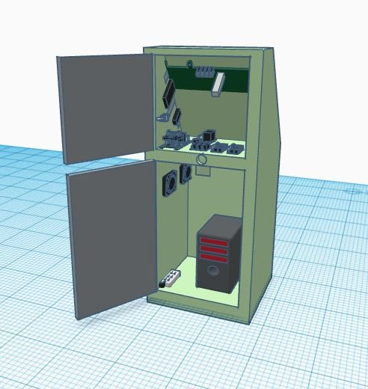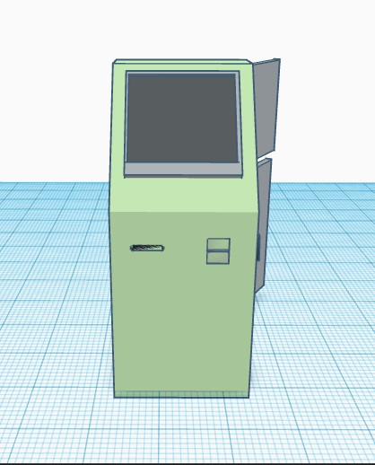

**Figure 19.**Structural Design of the Payment Kiosk

## Appendix O

### User Manual

**User Manual for subdivision payment kiosk**

**(PAYSYNC)**

**Figure 21.** Welcome message prompting to get started

**Introduction**

Thank you for choosing our **Arduino-Based Subdivision Payment Kiosk System**. This user manual will provide you with all the necessary information to effectively operate and utilize the kiosk. Please read this manual carefully before using the kiosk.

**Table of Contents**

1. Safety Instructions 81

2. Overview81

3. Features 81

4. Getting Started81

4.1. For Administrative Use81

4.2. For Homeowner Use 80

Troubleshooting80

Maintenance and Cleaning80

Technical Specifications80

Warranty & Support 80

1. **Safety Instructions**

Ensure the kiosk is placed on a stable and level surface. Do not expose the kiosk to extreme temperatures or direct sunlight. Keep the kiosk away from liquids and flammable substances. Do not insert any foreign objects into the kiosk's payment slot. Disconnect the power supply before cleaning or performing any maintenance.

1. ***Overview***

The **Arduino-Based Subdivision Payment Kiosk System** is a self-service machine designed to facilitate the payment of maintenance fees limited to cash only.

1. ***Features***

* User-friendly interface with a touchscreen display.
* Cash payment options for accessibility.
* Real-time payment status updates.
* Receipt printing for transaction records.
* Admin module to manage Homeowners, Bills in the system along with Reports which helps in maintaining accounts.

1. ***Getting Started***

Connect the kiosk to a power source using the provided power cable. Wait for the kiosk to initialize and display the main screen.

***4.1. For Administrative Use***

Login using the given administrative credentials. It will show Member List screen with menu option. Features of the System can be found in the Menu Options as

* Member List
  + Add Individual Bill
  + View Individual Bill
    - Edit Bill
    - Delete Bill
  + Edit
  + Download Member List
* New Members
* Generate Bill
* Report
  + Download Received Amount
  + Pending Amount
    - Download Pending Amount

Detail explanation of available options

* 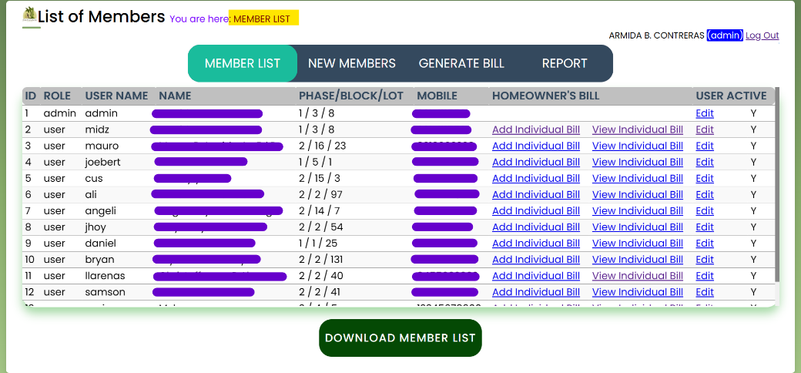**Member List**

**Figure 23.** **Member List screen** shown after Administrative Successful login

Displays all home owner member list, with link to Add Bill, View Bill & Edit Member details

* + 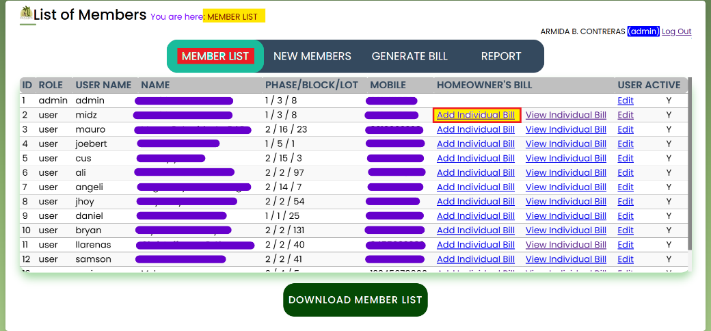**Add Individual Bill**

**Figure 24.** **Add Individual Bill Screen** Shown after clicking the link from Member List

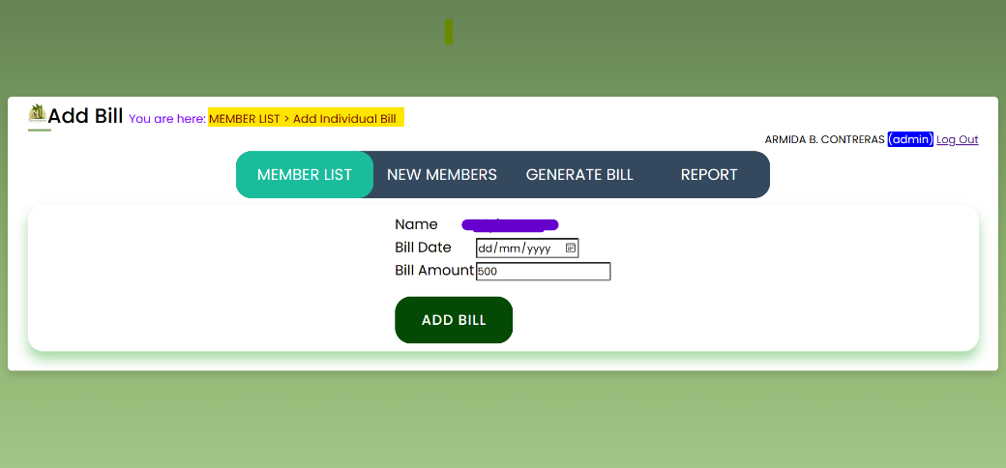

Allows to add Maintenance Bill (VMF) Bill for respective homeowner

* + 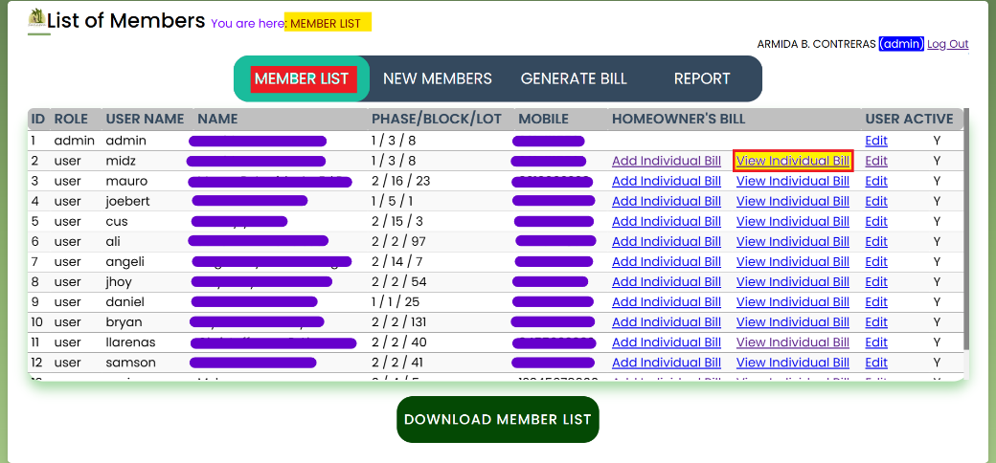**View Individual Bill**

**Figure 25. View Individual Bill Screen** shown after clicking the link from Member List

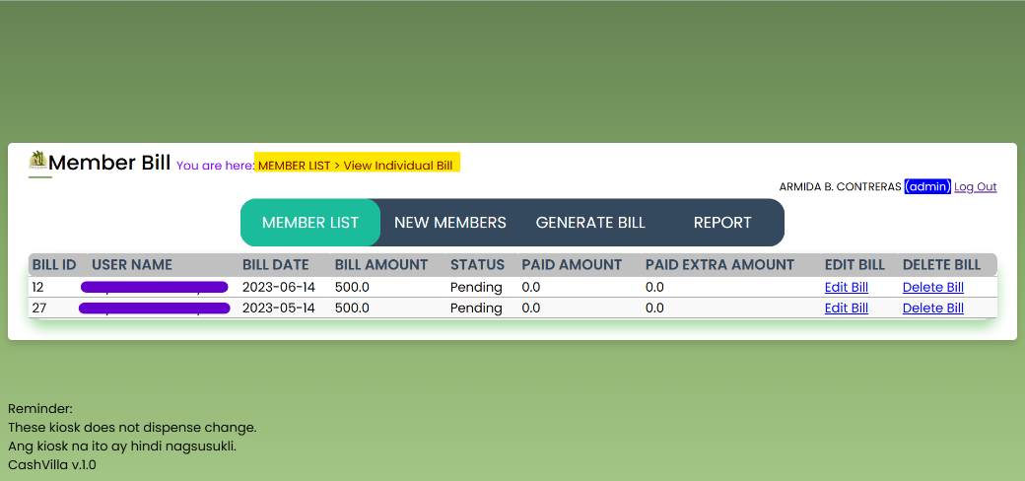

Allows to view VMF Bill along with status for respective homeowner

* + - **Edit Bill**

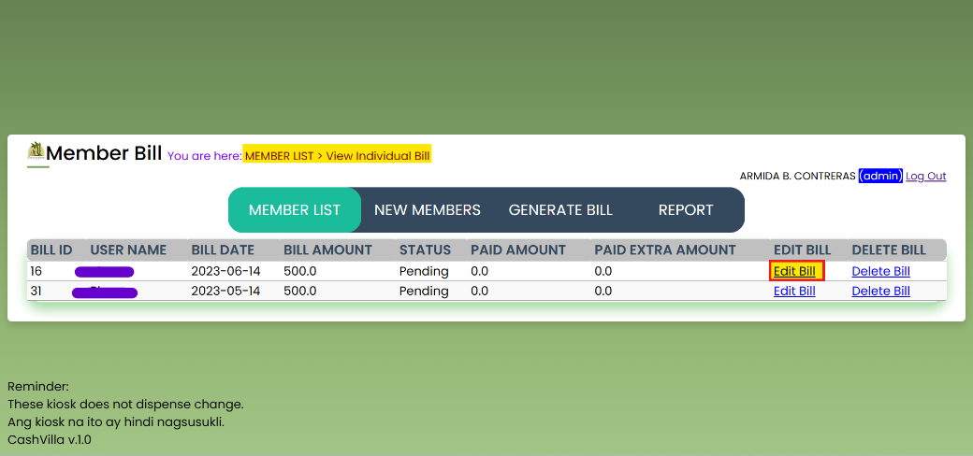

**Figure 26.** **Edit Individual Bill Screen** shown after clicking the link from Member List

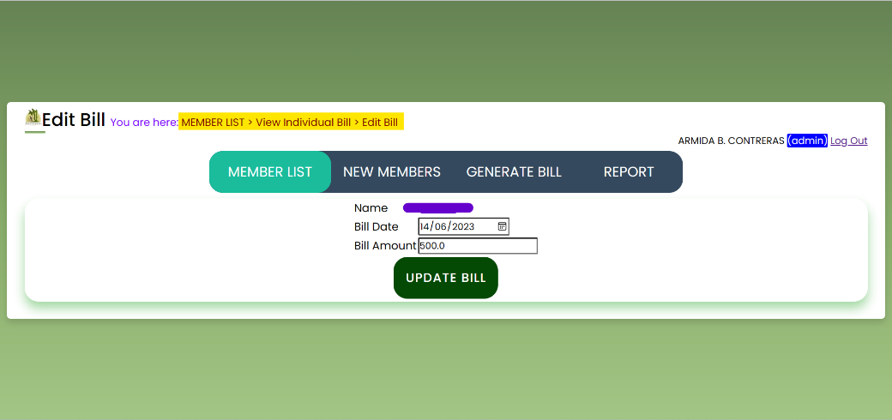

Allows to edit VMF Bill for respective homeowner

* + 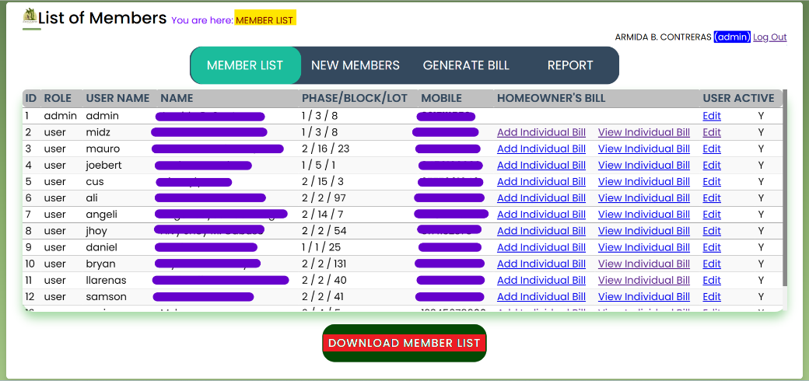**Download Member List**

**Figure 27. Download Member List Screen** shown after clicking the link from Member List

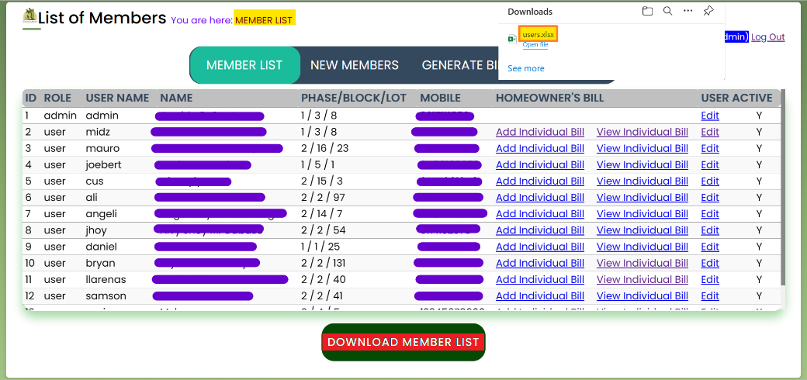

*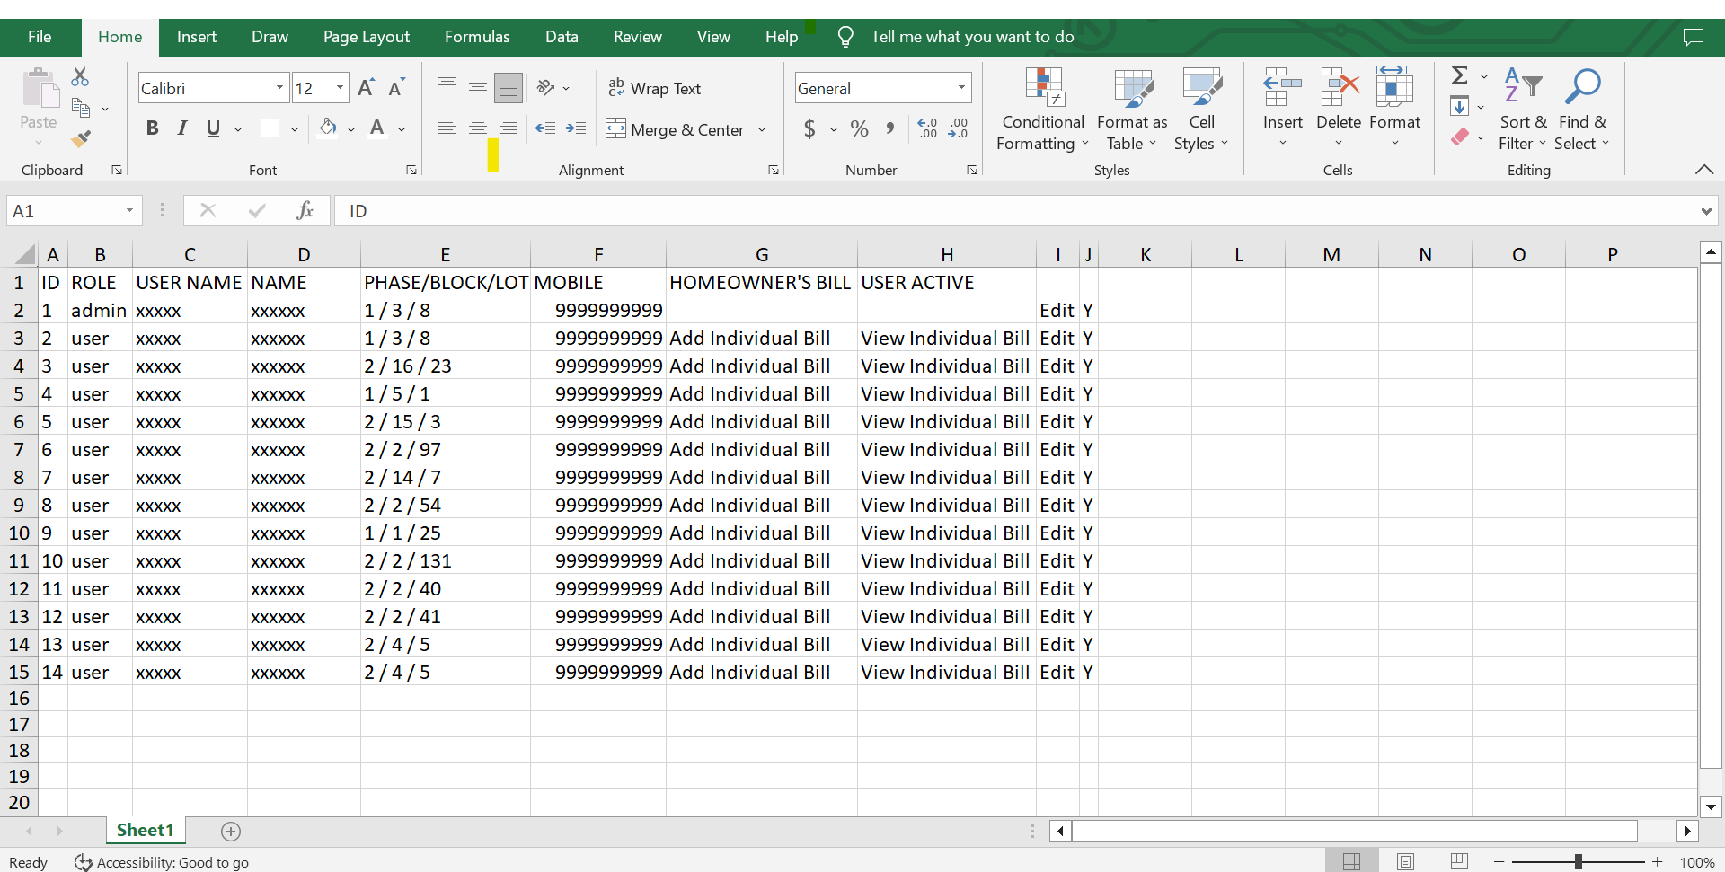Allows to download member list in excel which can be copied over by using thumb drive for administrative purpose.*

**Figure 28.** **Excel File Downloaded** after clicking button from member list

* 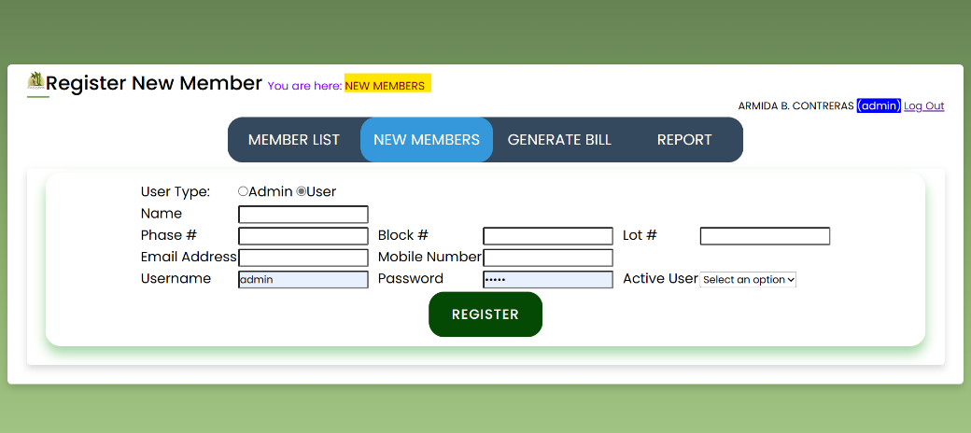**New Members**

**Figure 29.** **New Homeowner Registration Screen** shown after clicking the option from menu

*Allows to register new Homeowners in the system*

* ***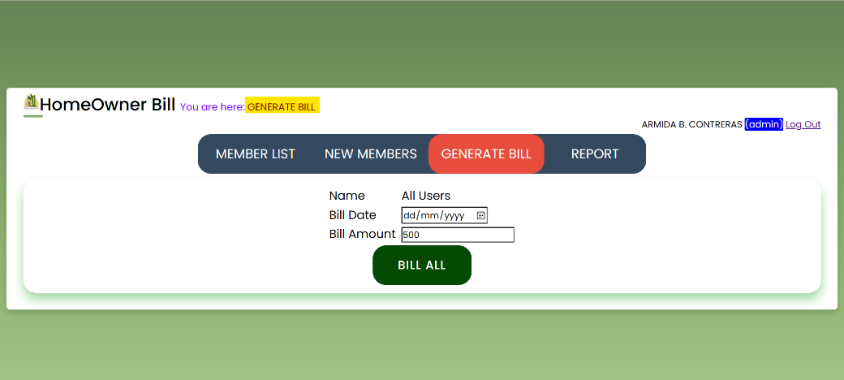*Generate Bill**

**Figure 30.** **Generate Bill Screen** shown after clicking the option from menu

*Allows to generate bills for respective Homeowners*

* *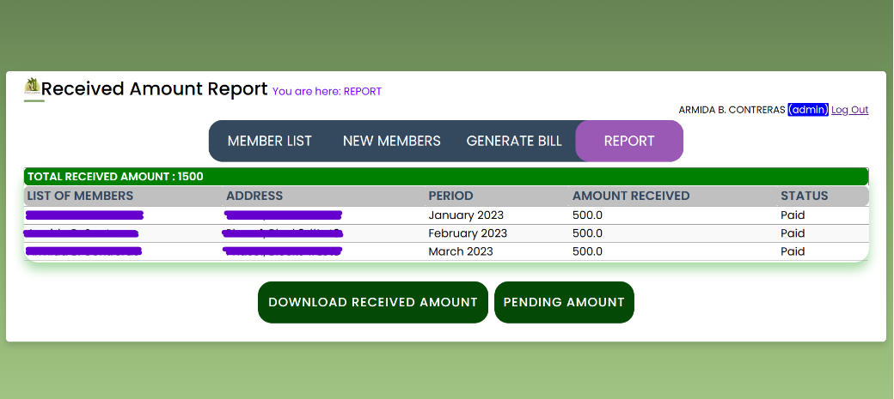***Report**

**Figure 31.** **Report Screen** shown after clicking from menu option

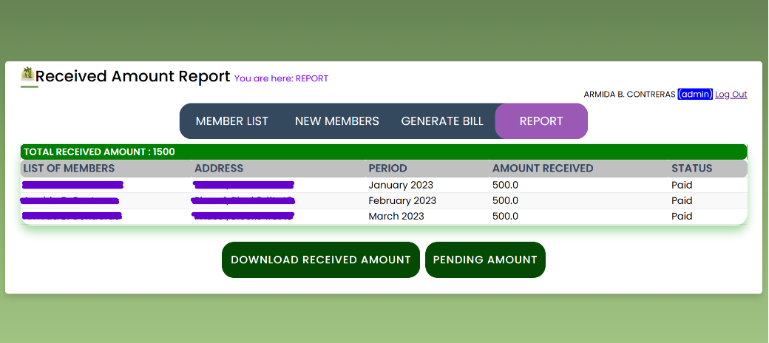

**Figure 32. Downloaded Received Amount** screen after clicking button from Report

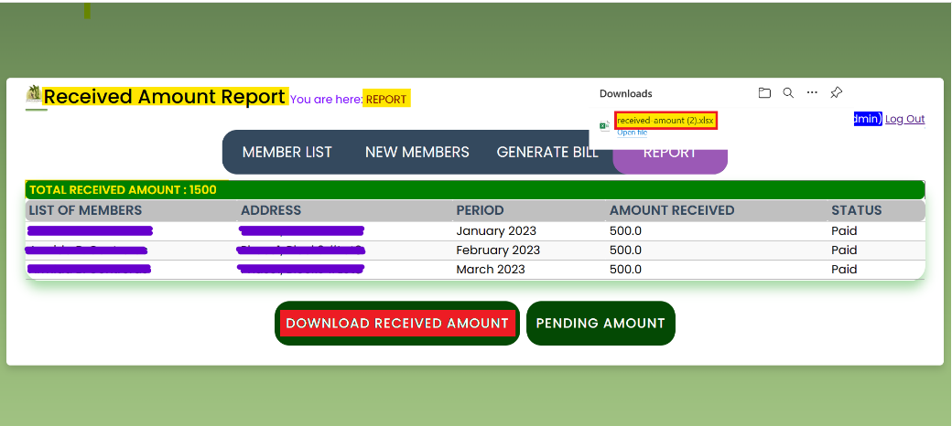

*Allows to download report which shows details of the homeowners who paid their VMF bills in excel which can be copied over by using thumb drive for administrative purpose.*

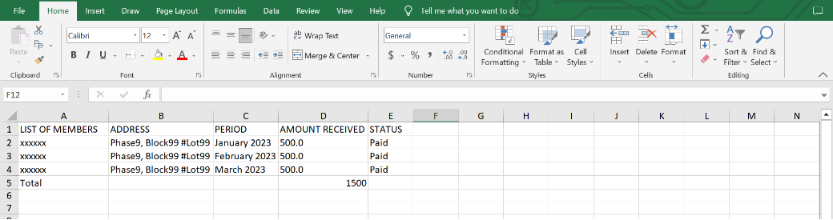

***Figure 33.******Excel File Downloaded*** *after clicking button from Report menu*

* + *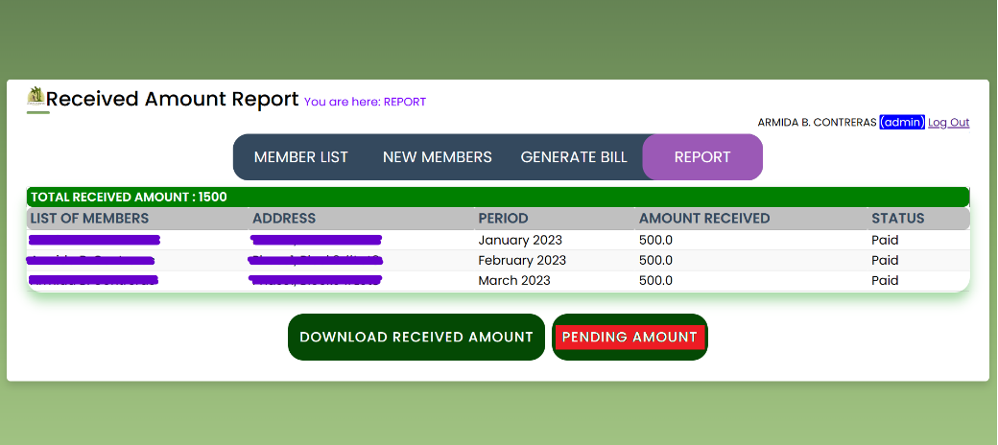***Pending Amount**

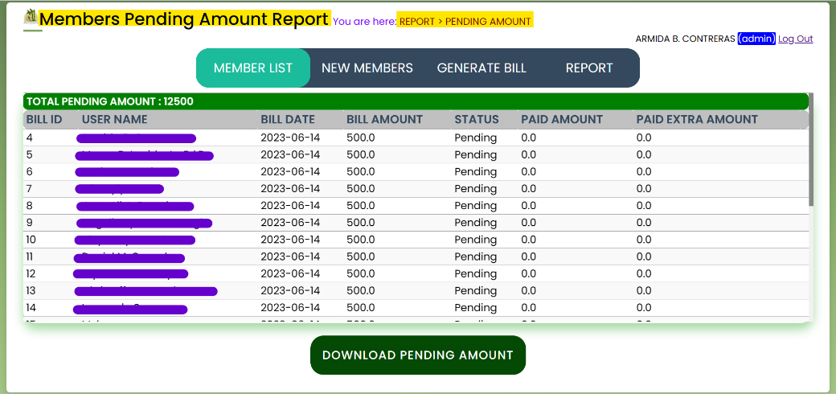**Figure 34.** **Download Pending Amount Screen** shown after clicking button from Report Screen

*Allows to download report which shows details of the homeowners who haven’t paid their VMF bills in excel which can be copied over by using thumb drive for administrative purpose.*

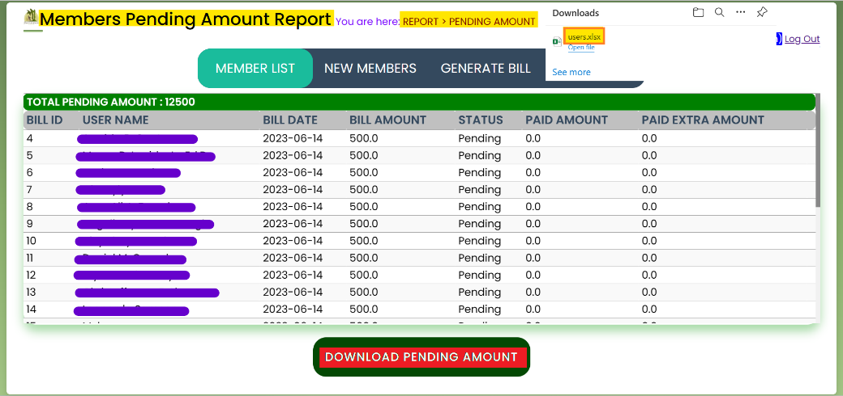

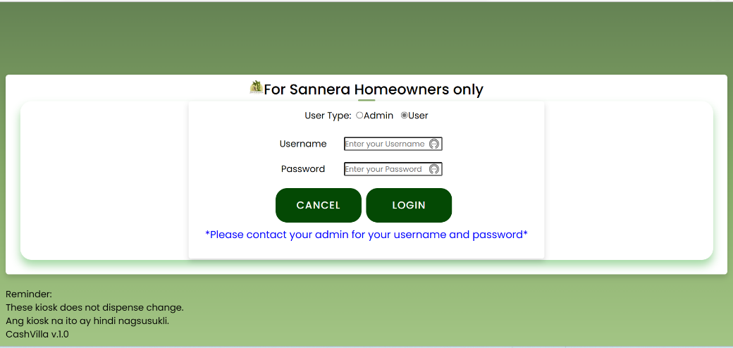***4.2. For Homeowner Use***

**Figure 35.** **Login Screen** selection of User Option

Login using the given user (Homeowner) credentials. It will show Data Privacy Consent screen followed by My Profile screen with menu option.

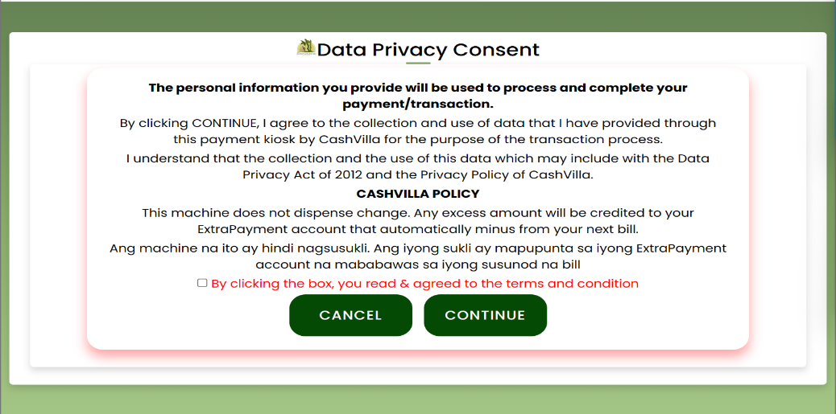

***Figure 36.*** **Data Privacy Consent Screen** shown after Homeowner Successful login for User agreement of terms & conditions

Features of the System can be found in the Menu Options as

* My Profile
  + Change Password
* My Bill
  + Pay Bill
    - Pay Now
* Past Payments

Detail explanation of available options

* My Profile

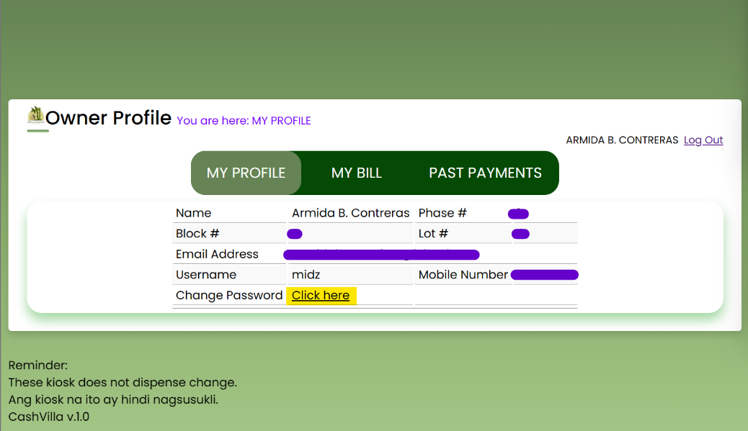

**Figure 37.** **My Profile screen** shown after Data Privacy screen

Displays Profile of logged in Homeowner, with link to Change Password

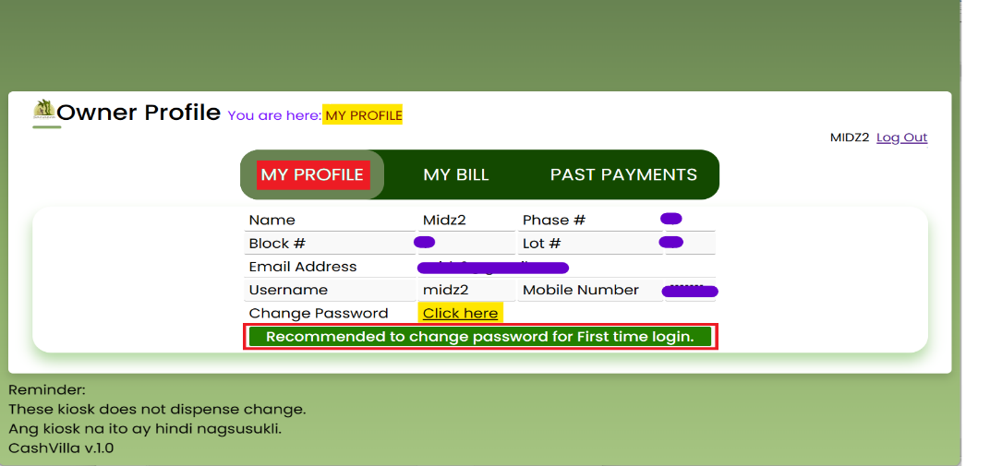

**Figure 38.** **My Profile - Recommended To Change Password screen** shown after login for first time login homeowner user after Data Privacy Screen

Displays screen to change password with “recommendation to change password” for first time login homeowner user

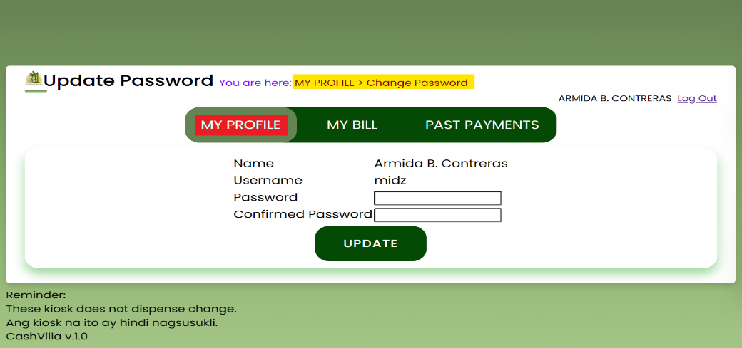

**Figure 39.** **Update Password screen** shown after clicking change password link

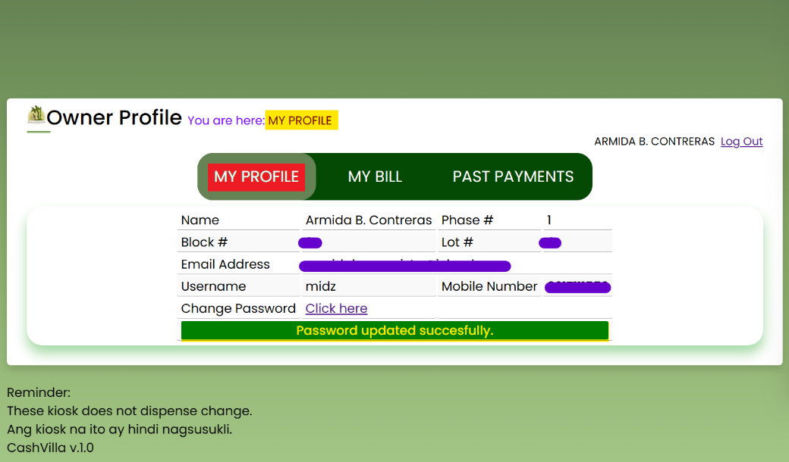Displays screen to change password

**Figure 40.** **Update Password screen** shown after clicking change password link

Displays screen with message to change password

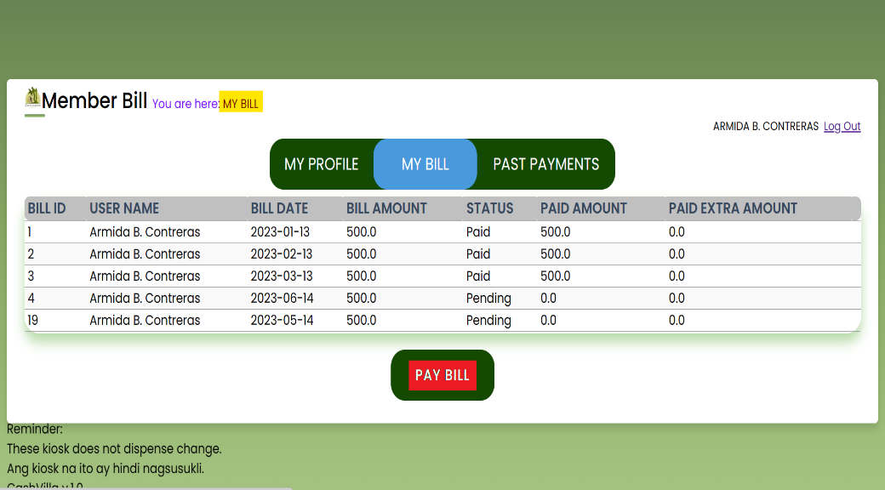

**Figure 41.** **My Bill screen** shown after clicking from menu option

Displays logged in users all VMFs bills with status Paid, Pending & option button Pay Bill

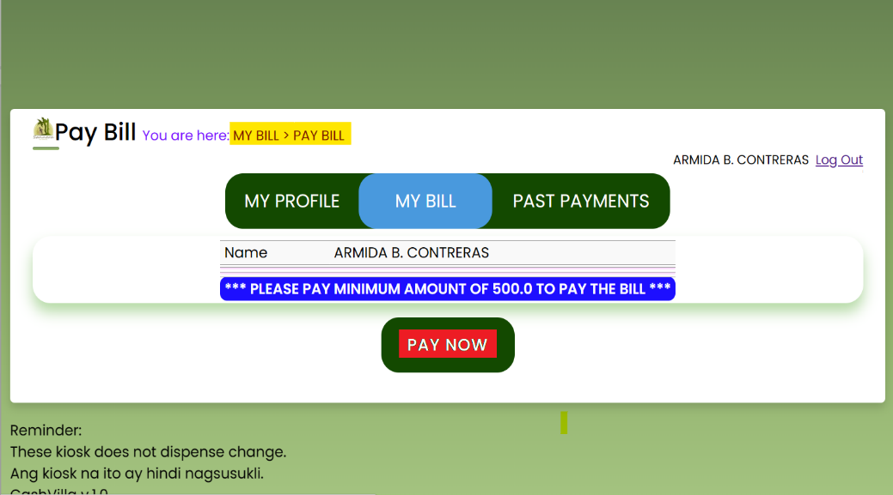

**Figure 42.** **Pay Now screen** shown after clicking **Pay Bill** button from **My Bill** screen

Displays screen for paying the bill by clicking Pay Now button

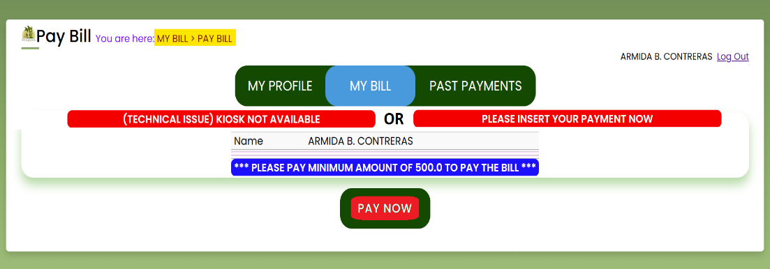

**Figure 43.** **Pay Now screen** shown with 2 messages as seen

Displays screen with message “(TECHNICAL ISSUE) KIOSK NOT AVAILABLE” if kiosk is not able to operate or either displays “PLEASE INSERT YOUR PAYMENT NOW”

Option 2 allows them to update user details.

Option 3 enables them to delete a user.

Option 4 allows you to download a list of users into an Excel file.

Additionally, the flowchart includes a decision point where the admin can choose to download a sales report. If they decide to do so, the report file will be generated. (Throughout the process, various actions are performed based on the user's choices, such as displaying member details, showing a registration form, totaling received payment amounts, adding bills to homeowners, editing user details, and deleting user accounts.)

For homeowners use:

Agree to the terms and conditions.

Login using the given credentials. (Upon successful login, the system presents the user with a menu displaying various options. The user can choose an option from the menu, and the subsequent actions depend on the selected choice.)

If the user selects Option 1, the system will display the homeowner's information.

If the user selects Option 2, the system will display the bill information, followed by the option to pay the bill. If the user chooses to make a payment, the system will present the payment page.

To proceed with the payment, the user should click the "start payment" button, which initiates the payment process.

Alternatively, the user can choose another option from the menu or end the process by selecting the logout option.

After clicking the "start payment" button, the user will be prompted to insert cash for payment. Once the payment is completed, the user needs to confirm, and the system displays the amount that was inserted.

Finally, the user must submit the payment by clicking the "submit payment" button, which will redirect them to a page where the receipt is displayed.

The user has the option to print or not print the receipt. Regardless of the choice made, the system will automatically log out.

Lastly, if the user selects Option 3, the system displays the transaction records. The process then proceeds to the next step, where the user is prompted to log out of the system.

If the user chooses to log out, the process ends.

If the user wishes to continue interacting with the system, the process returns to the menu options.

Troubleshooting:

If the kiosk is unresponsive, restart it by disconnecting and reconnecting the power supply. For payment-related issues, contact the designated customer support number displayed on the kiosk.

Maintenance and Cleaning:

Regularly clean the touchscreen with a soft, lint-free cloth. Use mild cleaning agents and avoid abrasive materials. Ensure the payment slot is free from debris and obstructions.

Technical Specifications:

Dimensions: 630”x1800” Power Supply: 220V

customer support team at: